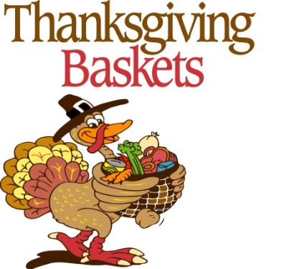
LSLC Thanksgiving Basket Drive
Deadline November 15 at 11 A.M.
LSLC is planning to help the families served by Artemis House Shelter to celebrate Thanksgiving. Many do not even have a car to get to a store to buy food. We will be working with the shelter staff to ensure the families have an opportunity to shop for perishables if we can provide the non-perishables and funds for the shopping trip. Through an endowment challenge, Social Ministry will provide gift cards for turkeys once commitments for 25 baskets are received.
We need 40 baskets this year:
- Non-Perishables: canned cranberries (2); canned green beans (4); canned carrots (4); rice (2-3 lbs.); canned/jarred gravy (2); canned yams (1 large or 2 small); apple sauce (1 jar/can); apple juice (1/2 gallon); & stuffing (1 bag/box).
- Perishables: $15 gift certificates for butter, rolls, onions, celery and dessert.
- Turkey Donations Needed: We need 25 folks to donate $25 for each turkey for LSLC’s Thanksgiving Basket Drive in support of Shelter House/NOVACO. Potential Match: $375 for 15 more turkeys!
Please use this link to sign up for items: (You can sign up for multiple items.)
https://www.signupgenius.com/go/4090A48A5A62B0-thanksgiving
Items can be dropped off at church in boxes provided by Nov. 15 at 11:00am. Gift certificates should be left in the office.
If you prefer to send a check by mail, please earmark it for “Thanksgiving Baskets.”
For More Information contact Steve or Bonnie Thomas: bandsthomas@verizon.net
Helping others enjoy Thanksgiving is a way of giving thanks to the Lord.

